**컴퓨터그래픽스 Lab04 보고서**

|  |  |  |
| --- | --- | --- |
| **학번** | **이름** | **분반** |
| 2312282 | 임다희 | 003 |

**[과제 1] 정의된 정육면체를 보여주는 코드**

**결과**

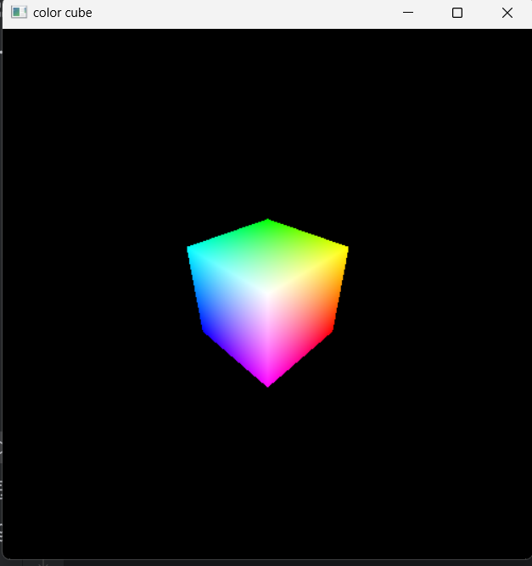

**코드**

from OpenGL.GL import *

from OpenGL.GLUT import *

from OpenGL.GLU import *

vertices = ((-1.0,-1.0,-1.0),(1.0,-1.0,-1.0),

<--- 큐브 모델의 각 점과 색상을 지정한다.

(1.0,1.0,-1.0), (-1.0,1.0,-1.0), (-1.0,-1.0,1.0),

(1.0,-1.0,1.0), (1.0,1.0,1.0), (-1.0,1.0,1.0))

colors = ((0.0,0.0,0.0),(1.0,0.0,0.0),

(1.0,1.0,0.0), (0.0,1.0,0.0), (0.0,0.0,1.0),

(1.0,0.0,1.0), (1.0,1.0,1.0), (0.0,1.0,1.0))

xRot = 30.0

yRot = 30.0

def polygon( a, b, c , d):

glBegin(GL_POLYGON)

<--- 큐브 모델을 구성하는 폴리곤을 정의하는 함수이다. .

glColor3fv(colors[a])

glVertex3fv(vertices[a])

glColor3fv(colors[b])

glVertex3fv(vertices[b])

glColor3fv(colors[c])

glVertex3fv(vertices[c])

glColor3fv(colors[d])

glVertex3fv(vertices[d])

glEnd()

def colorcube():

polygon( 0,1,2,3)

<--- 큐브 모델의 각 면이 될 폴리곤을 총 6개 생성한다.

폴리곤은 면을 구성하는 주어진 점 4개를 반시계 방향으로 나열하여 생성한다.

polygon(0,1,5,4)

polygon( 4,5,6,7)

polygon( 5,1,2,6)

polygon(6,2,3,7)

polygon( 4,7,3,0)

def MyDisplay():

global myview

glClear(GL_COLOR_BUFFER_BIT | GL_DEPTH_BUFFER_BIT)

glLoadIdentity()

gluLookAt(3.0, 3.0, 3.0, 0.0, 0.0, 0.0, 0.0, 1.0, 0.0)

colorcube()

glutSwapBuffers()

def myReshape(w, h):

glViewport(0, 0, w, h)

glMatrixMode(GL_PROJECTION)

glLoadIdentity()

# glFrustum (left, right, bottom, top, near distance, far distance)

if w <= h:

glFrustum(-2.0, 2.0, -2.0 * float(h)/ float(w), 2.0* float(h) / float(w), 2.0, 20.0)

else:

glFrustum(-2.0, 2.0, -2.0 * float(w)/ float(h), 2.0* float(w) / float(h), 2.0, 20.0)

glMatrixMode(GL_MODELVIEW)

def main():

glutInit(sys.argv)

glutInitDisplayMode(GLUT_DOUBLE | GLUT_RGB | GLUT_DEPTH)

glutInitWindowSize(500, 500)

glutCreateWindow('color cube')

glutReshapeFunc(myReshape)

glutDisplayFunc(MyDisplay)

glutAttachMenu(GLUT_RIGHT_BUTTON)

glEnable(GL_DEPTH_TEST)

glutMainLoop()

if __name__ == "__main__":

main()

**[과제 2] 큐브를 x축으로 45도 회전한 모습 보여주는 코드**

**결과**

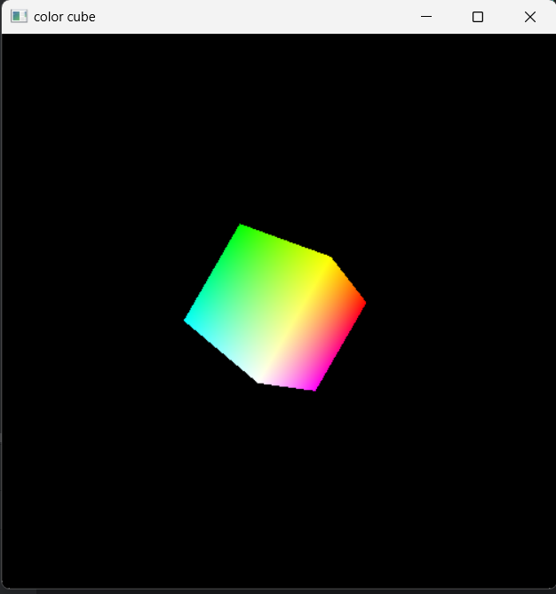

**코드**

from OpenGL.GL import *

from OpenGL.GLUT import *

from OpenGL.GLU import *

vertices = ((-1.0,-1.0,-1.0),(1.0,-1.0,-1.0),

(1.0,1.0,-1.0), (-1.0,1.0,-1.0), (-1.0,-1.0,1.0),

(1.0,-1.0,1.0), (1.0,1.0,1.0), (-1.0,1.0,1.0))

colors = ((0.0,0.0,0.0),(1.0,0.0,0.0),

(1.0,1.0,0.0), (0.0,1.0,0.0), (0.0,0.0,1.0),

(1.0,0.0,1.0), (1.0,1.0,1.0), (0.0,1.0,1.0))

xRot = 30.0

yRot = 30.0

def polygon( a, b, c , d):

glBegin(GL_POLYGON)

glColor3fv(colors[a])

glVertex3fv(vertices[a])

glColor3fv(colors[b])

glVertex3fv(vertices[b])

glColor3fv(colors[c])

glVertex3fv(vertices[c])

glColor3fv(colors[d])

glVertex3fv(vertices[d])

glEnd()

def colorcube():

polygon( 0,1,2,3)

polygon(0,1,5,4)

polygon( 4,5,6,7)

polygon( 5,1,2,6)

polygon(6,2,3,7)

polygon( 4,7,3,0)

def MyDisplay():

global myview

glClear(GL_COLOR_BUFFER_BIT | GL_DEPTH_BUFFER_BIT)

glLoadIdentity()

gluLookAt(3.0, 3.0, 3.0, 0.0, 0.0, 0.0, 0.0, 1.0, 0.0)

glRotatef(45,1,0,0)

<--- glRotatef 함수로 회전의 각도, 회전 방향을 지정한다.

각도는 45도, 방향은 1,0,0으로 x축으로 45도만큼 회전하게 한다.

colorcube()

glutSwapBuffers()

‘’’나머지는 1번 코드와 동일 ‘’’

**[과제 3] 큐브를 z축으로 45도 회전한 모습 보여주는 코드**

**결과**

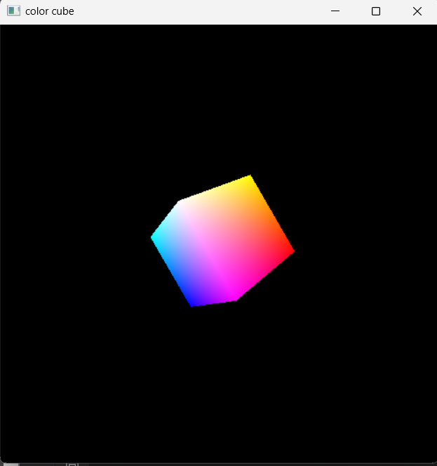

**코드**

from OpenGL.GL import *

from OpenGL.GLUT import *

from OpenGL.GLU import *

vertices = ((-1.0,-1.0,-1.0),(1.0,-1.0,-1.0),

(1.0,1.0,-1.0), (-1.0,1.0,-1.0), (-1.0,-1.0,1.0),

(1.0,-1.0,1.0), (1.0,1.0,1.0), (-1.0,1.0,1.0))

colors = ((0.0,0.0,0.0),(1.0,0.0,0.0),

(1.0,1.0,0.0), (0.0,1.0,0.0), (0.0,0.0,1.0),

(1.0,0.0,1.0), (1.0,1.0,1.0), (0.0,1.0,1.0))

xRot = 30.0

yRot = 30.0

def polygon( a, b, c , d):

glBegin(GL_POLYGON)

glColor3fv(colors[a])

glVertex3fv(vertices[a])

glColor3fv(colors[b])

glVertex3fv(vertices[b])

glColor3fv(colors[c])

glVertex3fv(vertices[c])

glColor3fv(colors[d])

glVertex3fv(vertices[d])

glEnd()

def colorcube():

polygon( 0,1,2,3)

polygon(0,1,5,4)

polygon( 4,5,6,7)

polygon( 5,1,2,6)

polygon(6,2,3,7)

polygon( 4,7,3,0)

def MyDisplay():

global myview

glClear(GL_COLOR_BUFFER_BIT | GL_DEPTH_BUFFER_BIT)

glLoadIdentity()

gluLookAt(3.0, 3.0, 3.0, 0.0, 0.0, 0.0, 0.0, 1.0, 0.0)

glRotatef(45,0,0,1)

<--- glRotatef 함수로 회전의 각도, 회전 방향을 지정한다.

각도는 45도, 방향은 0,0,1으로 z축으로 45도만큼 회전하게 한다.

colorcube()

glutSwapBuffers()

‘’’나머지는 1, 2번과 동일 ‘’’